7 leс. The functioning of the security management system

The purpose of the information security system is:
1) in organizing the management of the information security system through the effective functioning of the system of its provision;
2) in creating the necessary economic and sociocultural conditions and legal and organizational mechanisms for the formation, development and ensuring the effective use of national information resources in all spheres of life and work of a citizen, society and the state.

Conditions for the functioning of security systems
The volume and composition of the equipment used in each of the systems included in the complex of technical means for ensuring the safety of the facility are determined by the necessary level of ensuring the safety of the facility and its personnel. The option of sharing several security systems at the facility can be selected on the basis of a compromise between the cost of losses from potential threats and the costs of implementing this option.
Priority for each security system are the requirements that ensure safety for the lives of people and the fire safety of the facility. Therefore, the main technical requirement for the security system is to provide the necessary functional and hardware reliability, fire safety and noise immunity. Reliability of a security system is understood as its property to detect with a given probability the penetration (attempted penetration) of a protected object (object zone).
The basic conditions for the functioning of the security system can be formulated as follows.
None of the subsystems in the security system should violate the mode of operation of the object, namely:
• the functions of jointly operating systems should complement each other, without exerting a mutual interfering effect on the performance of their components;
• in jointly operating systems, algorithmic compatibility and separate registration of service and alarm signals coming from them should be provided;
• requirements for operational reliability, sensitivity and noise immunity of one of the subsystems should not be inferior to the similar requirements for other subsystems working together with it, so as not to reduce the overall level of safety of the facility as a whole;
• failure of one or more subsystems or communication channels should not lead to failure of the entire security system.
The security system should be managed both centrally and decentralized with control over the level of personnel access to the system. The composition of the control and monitoring system for the functioning of jointly operating subsystems of the security system should be determined by their purpose. Automatic controls and controls are preferred; manual ones are allowed as duplicate ones. The appropriateness of duplication is determined by the requirements for ensuring the operational reliability of systems. Control and monitoring tools should be protected from possible erroneous actions of personnel.
The security system must maintain a good condition when exposed to environmental factors and restore a healthy state at the end of their impact.
The security system should not fail during a power outage at the facility and maintain a healthy state when a network or other main power source is disconnected during a power outage. Alarms should not give false alarms when switching power supplies from primary to backup and vice versa.

All events occurring in the system must be logged.
The system must control, test and protect itself from unauthorized access to management.
Jointly operating object systems of various functional purposes require a different response to the alarms and alarms issued by them; wherein:
• signals from various jointly operating systems, transmitted automatically for registration, must be recorded separately by control devices (compliance with this condition helps to prevent the danger of a “false call to a service”, that is, the response of one service of an object to signals intended for another service and / or acceptance by personnel of an object actions inadequate to the situation that has arisen);
• types and intensity of signals of systems for various purposes should be different (at the same time, sound alarms, alarm signals should not impede the use of voice, including telephone).
The system should not pose a threat to the security object.
In each specific case of protection, the considered list may be limited or supplemented by additional conditions.

The principles of organization and functioning of the information security system
The organization and functioning of the information security system must comply with the following principles:
1. Complexity:
- ensuring the safety of personnel, material and financial resources from possible threats by all available legal means, methods and measures;
- ensuring the security of information resources throughout their entire life cycle, at all technological stages of their processing (conversion) and use, in all modes of operation;
- the ability of the system to develop and improve in accordance with changes in the operating conditions of the Bank.
2. Validity. The capabilities and means of protection used should be implemented at a modern and high-quality level of development of science and technology, justified from the point of view of a given level of security and comply with established requirements and standards of protection.
3. Improvement. It provides for the improvement of protective measures and means on the basis of own experience, the emergence of new technical means, taking into account changes in the methods and means of intelligence and industrial espionage, regulatory and technical requirements, achieved domestic and foreign experience.
4. Legality. It involves the development of a security system on the basis of federal legislation in the field of banking, informatization and information protection, private security activities and other safety regulations approved by government bodies within their competence, using all permitted methods for detecting and preventing violations.
5. Centralization of management. It assumes independent functioning of the security system according to unified legal, organizational, functional and methodological principles and centralized management of the security system.
6. Interaction and coordination. This principle means the implementation of security measures based on a clear relationship between the relevant units and services, third-party specialized organizations in this field, coordination of their efforts to achieve their goals, as well as cooperation with interested associations and interaction with government and law enforcement agencies.
7. Legality. It involves the development of a security system on the basis of federal legislation in the field of banking, informatization and information protection, private security activities and other safety regulations approved by government bodies within their competence, using all permitted methods for detecting and preventing violations.
8. Continuity. The principle of constant maintenance of the entire security system in the current state and its improvement in accordance with the changing conditions of the bank.
9. Specialization. It is supposed to involve specialized organizations in the development and implementation of measures and means of protection that are most prepared for a specific type of security activity, have practical experience and a state license to provide services in this area. The operation of technical equipment and the implementation of security measures should be carried out by professionally trained specialists of the Bank's security service, its functional and service units.
The structural elements of TrustWorks security management system are Trusted Agents, Trusted GSM Server and Trusted GSM Console (Fig. 7.1).

Assignment of fixed security
The Trusted Agent installed on the client’s personal computer is focused on protecting an individual user, who usually acts as a client in client-server applications.

The security agent installed on the application server is focused on securing the server components of distributed applications.

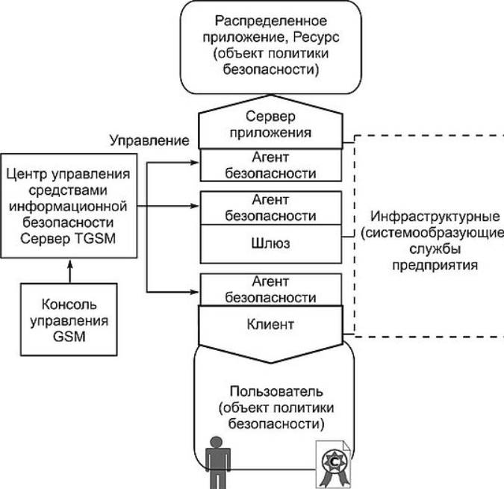

Fig. 7.1. General block diagram of the asset management system
information security

The security agent installed on the gateway computer ensures the isolation of network segments within the enterprise or between enterprises.

The Trusted GSM Server provides a description and storage of global network-wide security policies, translates global policies into local security policies for security devices, loads security devices, and monitors the status of all system agents. To organize a distributed enterprise security management scheme in the GSM system, it is planned to install several (up to 65,535) GSM servers.

The management console (Trusted GSM Console) is designed to organize the workplace of the system administrator (s). For each of the GSM servers, several consoles can be installed, each of which is configured according to the role rights of each of the administrators of the GSM system.

A local Security Agent (Trusted Agent) is a program that is hosted on a terminal device (client, server, gateway) and performs the following security functions:

• authentication of security policy objects, including integration of various authentication services;
• definition of the user in the system and events associated with this user;
• ensuring centralized security management and access control;
• resource management for applications, support for managing access to application-level resources;
• protection and authentication of traffic;
• traffic filtering;
• event logging, monitoring, alarming.
Additional Trusted Agent Features:

• cryptoservice delivery (multiple concurrent pluggable modules);
• Perimeter management of Single Sign-On (as a sub-task of user authentication);
• service for secure applications (crypto service, PKI access service, access to security management);
• traffic compression (IPcomp, pluggable module);
• Network Reservation Management (QoS);
• functions of the local network anti-virus protection agent.
The central element of the local agent is the local security policy processor (LSP processor), which interprets the local security policy and distributes calls between the other components.

Resource Protection

Authentication and access authorization. As part of the solution, authentication schemes of various functionalities are implemented, each of which includes an authentication type and an object identification method (mechanism).

The following options are provided for choosing an authentication type: user authentication when accessing a GSM or local OS environment, user authentication when accessing a network (network segment), mutual network authentication of objects (application-application). The following options are provided for choosing the method of idea -ification, suggesting their any joint use: token (smart card), password, “external” authentication.

Access control during network interactions. When initializing a secure network connection from the local OS or when receiving a request to establish an external connection, the local Trusted Agent security agents at the ends of the connection (and / or at the intermediate gateway) turn to the device LPS and check if this connection is allowed to be established. If such a connection is allowed, the required security service for this connection is provided, if prohibited, a network connection is not provided.

Access control at the level of application objects. For unprotected distributed applications in GSM, a service for restricting access rights at the level of internal objects of this application is provided. Access control at the level of application-level objects is ensured through the use of the proxy mechanism. A proxy is developed for each application protocol. The default protocol is http.

To build a distributed control scheme and reduce network load in GSM, the architecture of distributed proxies (Proxy Module as part of Trusted Agent) is used, each of which:

• has an abstract universal interface that provides modular connection of various rgo-filters;
• has an interface to the control system, but uses a temporary cache to manage filtering parameters, and filtering is controlled by generalized rules such as:
- authenticate subject X in the application object Y;
- allow access for subject X to object Y with parameters P;
- Deny access for subject X to object Z;
- the semantics of the rules for managing the rgo-filter and descriptions of subjects and access objects depend on the specific application protocol, however, the control center has the ability to register proxy filters and manage them in the context of an overall global security policy.
Proxy Agent can be installed on the Security Gateway, directly on the server executing the controlled applications, and on the client system site.
Security Management

The most important element of the Trust Works solution is a centralized, policy-based system for managing enterprise-wide network and information security tools. This system provides the following quality consumer features:

• a high level of security of the control system (by allocating a secure perimeter of control within the enterprise network);
• extensibility of information security management system;
• a high level of reliability of the control system and its key components;
• integration with corporate systems of general network and information management;
• A simple, intuitive, ergonomic, and infrastructural environment for describing, generating, monitoring, and diagnosing enterprise-level security policies (enterprise level policy based management).
Management is carried out by a special administrator software - Management Console (Trusted GSM Console). The number and functions of each of the instances of the Trusted GSM Console software installed in the system are set by the chief system administrator, depending on the organizational structure of the enterprise. To assign the functions of each of the Trusted GSM Console workstations, a role-based mechanism for differentiating rights for access to the management functions of the system is used.

GSM management features. Depending on the type of managed objects, the set of control functions in GSM can be divided into three categories.

1. Management of the information catalog. The information catalog management functions determine the GSM information component:
• formation of sections of the catalog;
• description of catalog services;
• assignment and control of network resources required to perform the service;
• registration of a service description;
• monitoring the status of services or sections of the service catalog;
• monitoring the performance of services;
• preparation and forwarding of reports (protocols) by the state of the catalog.
2. Management of users and access rights. To manage the access rights of system users to services (information or network resources), GSM provides the following functions:
• formation of user groups by roles and / or privileges of access to system services;
• formation of hierarchical aggregations of users according to administrative, territorial or other criteria (domains and / or departments);
• formation of user access roles to services (information or network resources);
• assignment of security levels for services and users of the system (support of a mandatory mechanism for delimiting rights);
• assignment of fixed access rights to groups, roles, user aggregations or individual users of the system to information or network resources of the system;
• preparing and sending reports (protocols) on user access to system services;
• preparing and sending reports (protocols) on the work of system administrators
3. Management of GPB rules. GPB rules match specific protection properties (both for network connections and user access to information services) to the predefined security levels of the system. Monitoring compliance with the rules of the GBS is performed by a special module as part of the system server - Security Policy Processor, which provides:
• definition of each of the security levels by a set of connection protection parameters, authentication schemes, and rights differentiation;
• Assignment of security levels to specific services or sections of the service catalog;
• assignment of security levels to users or any aggregations of system users (groups, roles, domains, departments);
• monitoring the integrity of the GPB (completeness of the rules);
• Calculation of the security policies of the LPS of local protection devices - security agents - and monitoring their implementation;
• monitoring the implementation of GPB according to various criteria;
• preparing and sending reports (protocols) on the state of the system and all attempts to violate the GBS.
Each of the system administrators is authenticated and works with the system through the Trusted GSM Console according to the rights predefined for it (to the resource catalog or its part, to the set of management functions defined by roles, to groups or other sets of users). All actions of any of the administrators are recorded and can be controlled in pairs.

